UPDATE #5 – March 24th 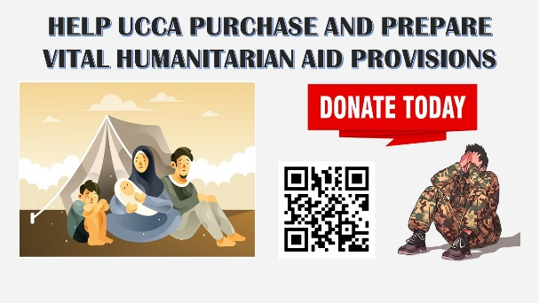
It has been 4 weeks since russia launched its unprovoked war against Ukraine. Their goal of overtaking Ukraine within days has been dashed - and as a result, the russian terrorist state has resorted to targeting civilians. After weeks of intense fighting, civilian casualties continue to mount across the country…
UCCA continues to scale up its response activities against the ever-growing needs across Ukraine.
Over the past seven days, the UCCA’s humanitarian aid Effort has…

Placed another order of $120,000 worth of IFAKs…
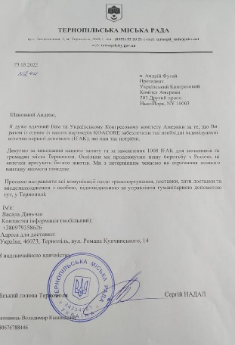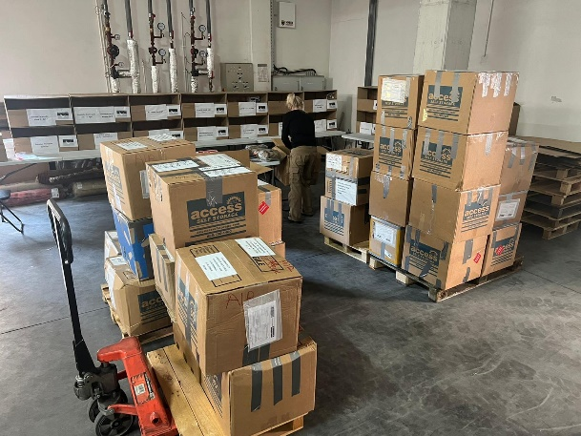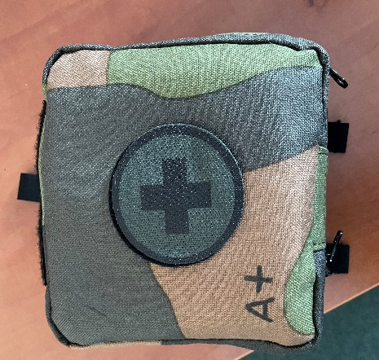
All the supplies have been delivered to our warehouse in Poland to put together the vital military first aid kits – IFAKs.
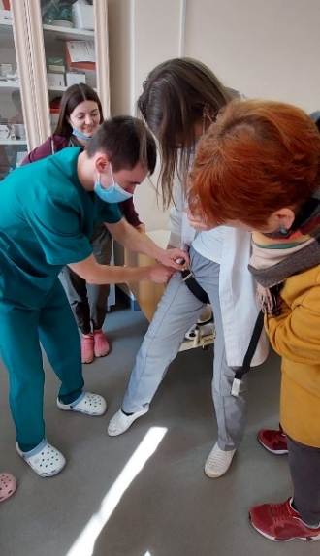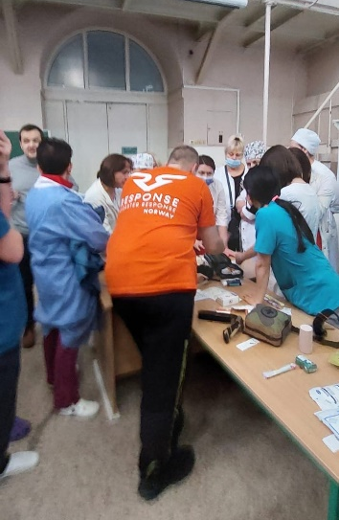
Previously delivered IFAKs kits, shown in photos, are being used in the Lviv hospital during training sessions.

Continued Shipping Humanitarian to Ukraine…
UCCA is grateful to all the contributors who have donated much needed medical supplies, first aid materials, hygiene products and military supplies. Leveraging its contacts, this week UCCA organized free transport for over 50 pallets that will be heading to Ukraine, via Poland.
Over 35 pallets of medical and military supplies – donated by Chalice of Mercy in Wisconsin left the warehouse in Harrison, NJ – and will be heading to Zaporizhzha.
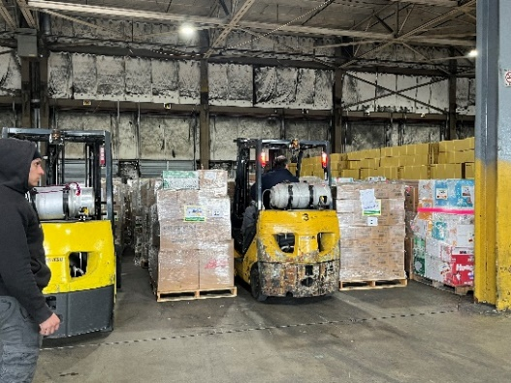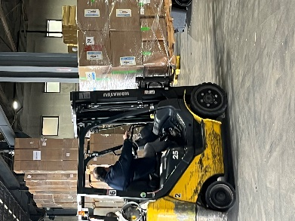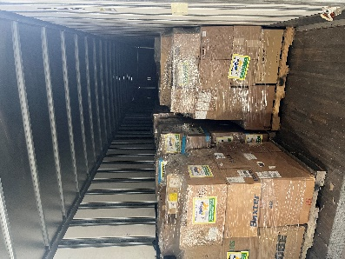
Another 16 pallets donated from East Coast Orthotic and Prosthetic Corp. will be heading to the Military Medical Clinic Center in Lviv, Ukraine in the coming week.

Continued supporting our partners on the ground…
UCCA continues to support AICM-Ukraine, which has moved its operations to Poltava where they rented a large warehouse of nearly 1500 sqm with some cold chain containers. This storage facility is large enough to group food, medicines, and other goods at the same place in a safe and clean space. This warehouse will be the biggest in the region and have the possibility to supply cities in the northern, eastern and southern portions of Ukraine.

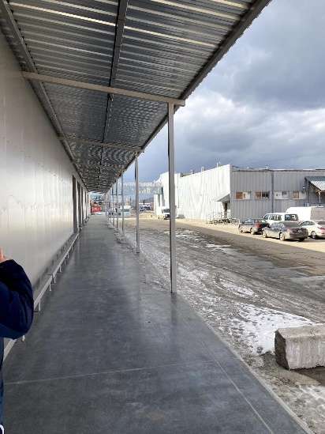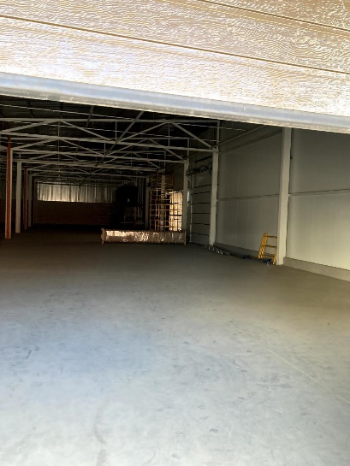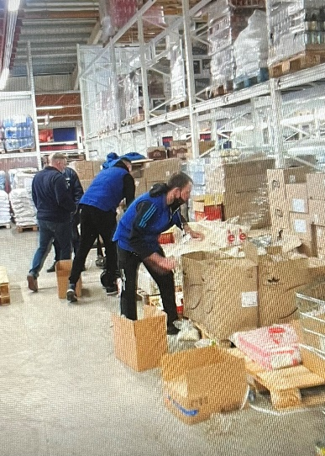
Responding to the grave humanitarian crisis caused by russia’s unprovoked war and its unrelenting civilian targeting, UCCA is supporting NGOs that do their utmost to help the most vulnerable civilians caught in the fighting, wherever they may be.
After being completely isolated for two week, AICM-Ukraine, in cooperation with the United Nations, arrived on March 18th, to deliver 7 trucks of life saving aid to the town of Sumy. Medicines for trauma care, food, hygienic kits, blankets and a large quantity of drinking water were distributed to the population of Sumy, a town of 250,000 inhabitants.
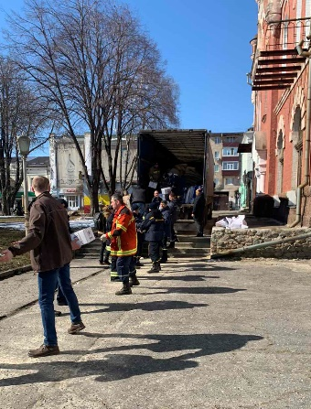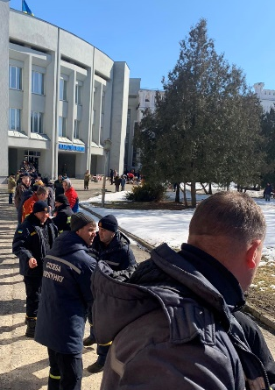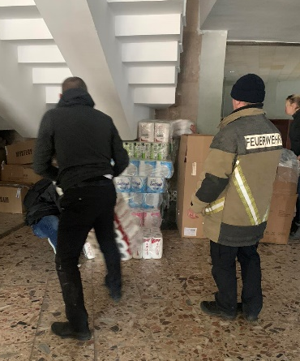

After the success in delivering vital aid to Sumy, our partner AICM-Ukraine prepared another convoy of critical aid for the towns isolated by the intense shelling in the governmental controlled area of Luhansk.

Feeding the Refugees…
UCCA continues to support a local food kitchen in Lviv that feeds up to 300 refugees and wounded servicemen each day. Lviv is a city where tens of thousands of displaced persons from various regions of Ukraine evacuate to or transit through; and its local population has worked to feed their fellow Ukrainians in their time of need.

Direct support for the Ukrainian Refugees in Poland…
During UCCA President’s quick trip to Poland, Andriy Futey distributed financial assistance to various organization that are providing direct support to the Ukrainians who are fleeing the ravages of war. Donations were provided to:
- World Central Kitchen - operating at the Registration Center in Mlyny
- Volunteer Kitchen – operating at the Krakow Train Station
- Immediate needs and supplies for the refugee families at the Registration Center in Mlyny, Poland
- Pomoc Dla Ukrainy - Допомога Україні – which provides transportation services for the fleeing Ukrainians, Krakow
- Assistance for refugee families (mothers with children) as well as single refugees (women) temporarily housed at the Ukrainian National Home – Przemysl
- Refugee families, individual refugees - (Mothers with children, grandmothers, families) at Border Crossing & Customs Control in Korczowa, Poland during visit with US Senate Delegation

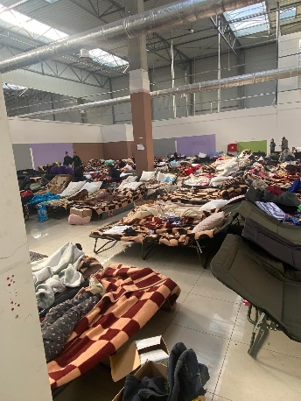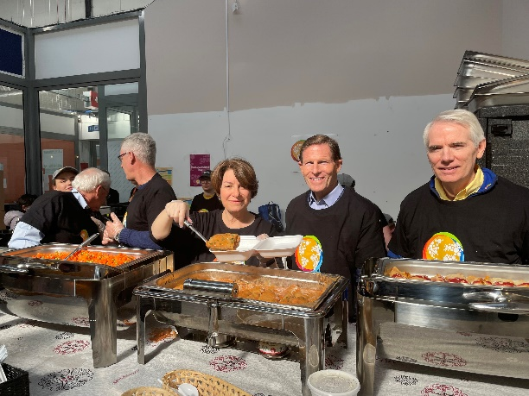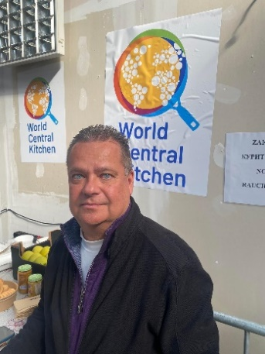
- Asociación Social DAMARK No Gubernamental Humanitaria - Association of Ukrainians Abroad, Humanitarian Convoy Ukrainian Refugees, which provided transportation of Ukrainians on two buses to Sevilla, Spain
- Ukrainian Greek Catholic Cathedral St. John the Baptist, Peremyshl

Spreading the word…
In an effort to inform our supporters and the public of the UCCA’s humanitarian efforts, UCCA is participating in various mediums to spread our word…
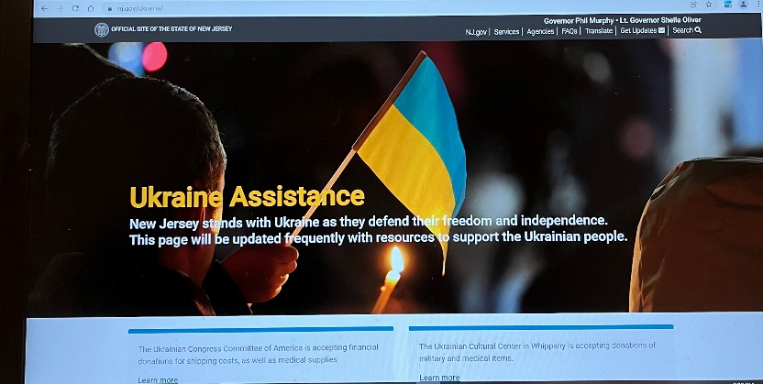
UCCA would like to thank Assemblyman Giblin for hosting UCCA on its half hour television show and NJ Governor, Phil Murphy, for listing UCCA on his official website under the tab on how to assist Ukraine - https://www.nj.gov/ukraine/

UCCA would also like to thank the Crane theater that held a Comedy Variety Event that raised awareness and funds for our humanitarian aid efforts. UCCA shared the proceeds from the event with the ProEnglish Theater of Ukraine who are currently sheltering artists in their theater in Kyiv and are in need of humanitarian support.

The Ukrainian Congress Committee of America would like to thank all our corporate sponsors and individual donors for their unwavering support!
It is thanks to their generous donations submitted via UCCA’s Mighty Cause platform, direct bank deposits, donations and charity events that UCCA is able to continue its vital humanitarian aid efforts.

#SupportUkraine Humanitarian Effort | Mightycause
Please know that every penny donated goes directly to our
humanitarian aid effort

NO money is being diverted at the top or
dedicated for administrative overhead.

